SCHOOL

Year 11 Examination, 2013

Question/Answer Booklet

MATHEMATICS: SPECIALIST 3A/3B
SOLUTIONS

Section One:

Calculator-free

Student Number: In figures

In words

Your name

Time allowed for this section
Reading time before commencing work: five minutes
Working time for this section: fifty minutes

Materials required/recommended for this section

To be provided by the supervisor
This Question/Answer Booklet
Formula Sheet

To be provided by the candidate
Standard items: pens, pencils, pencil sharpener, eraser, correction fluid/tape, ruler, highlighters

Special items: nil

Important note to candidates

No other items may be used in this section of the examination. It is your responsibility to ensure that you do not have any unauthorised notes or other items of a non-personal nature in the examination room. If you have any unauthorised material with you, hand it to the supervisor before reading any further.

Structure of this paper

Section | Number of questions available | Number of questions to be answered | Working time (minutes) | Marks available | Percentage of exam
Section One:  Calculator-free | 7 | 7 | 50 | 50 | 33
Section Two:  Calculator-assumed | 13 | 13 | 100 | 100 | 67
 |  |  | Total | 150 | 100

Instructions to candidates

- The rules for the conduct of Western Australian external examinations are detailed in the Year 12 Information Handbook 2013. Sitting this examination implies that you agree to abide by these rules.

- Write your answers in the spaces provided in this Question/Answer Booklet. Spare pages are included at the end of this booklet. They can be used for planning your responses and/or as additional space if required to continue an answer.
- Planning: If you use the spare pages for planning, indicate this clearly at the top of the page.
- Continuing an answer: If you need to use the space to continue an answer, indicate in the original answer space where the answer is continued, i.e. give the page number. Fill in the number of the question(s) that you are continuing to answer at the top of the page.

- Show all your working clearly. Your working should be in sufficient detail to allow your answers to be checked readily and for marks to be awarded for reasoning. Incorrect answers given without supporting reasoning cannot be allocated any marks. For any question or part question worth more than two marks, valid working or justification is required to receive full marks. If you repeat an answer to any question, ensure that you cancel the answer you do not wish to have marked.

- It is recommended that you do not use pencil, except in diagrams.

Section One: Calculator-free (50 Marks)
This section has seven (7) questions. Answer all questions. Write your answers in the spaces provided.

Working time for this section is 50 minutes.

Question 1 (6 marks)
Differentiate the following with respect to , simplifying your answers as far as possible.

(a) 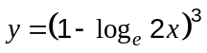 (2 marks)
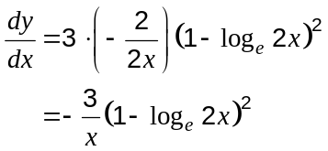

(b) 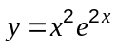 (2 marks)
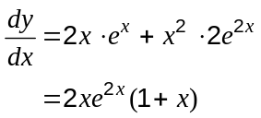

(c) 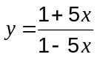 (2 marks)
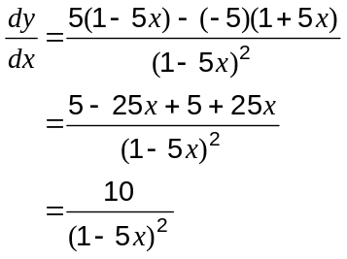

Question 2 (7 marks)
(a) If 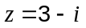, express 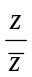 in simplified form. (2 marks)
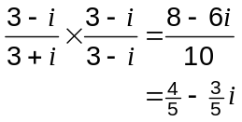

(b) Determine the complex number , if 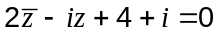. (5 marks)
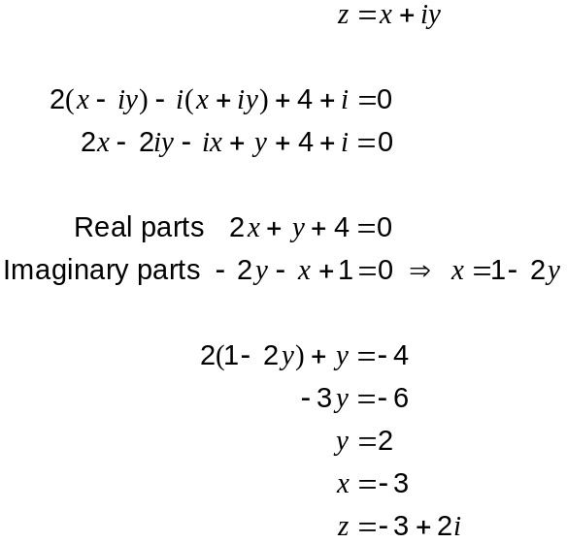
Question 3 (7 marks)
(a) Express in terms of if 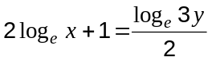. (3 marks)
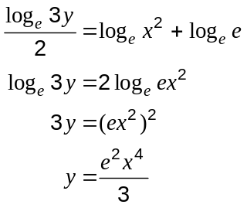

(b) Solve 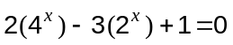. (4 marks)
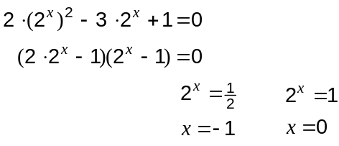

Question 4 (7 marks)
The function 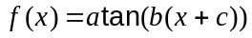 has been graphed below.
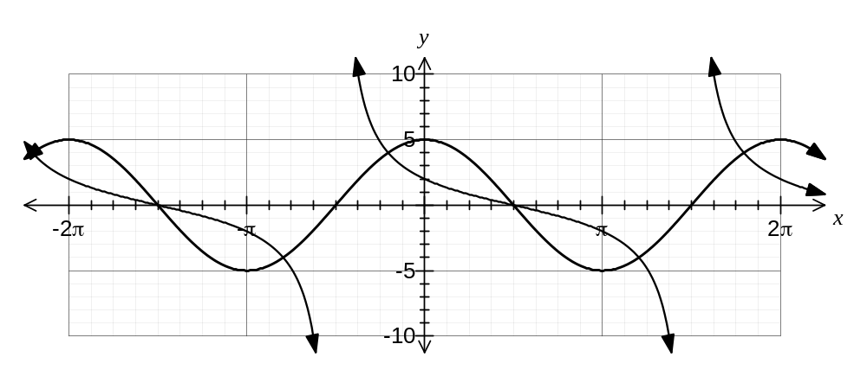

(a) Determine the values of the constants , and . (4 marks)

Period of 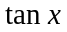 is ,  is 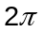, so 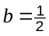.

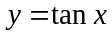 has a root at 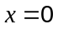. has root at , so 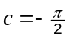.

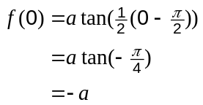 but 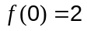 so 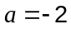

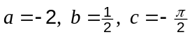

(b) On the same axes, sketch the graph of 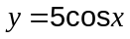. (2 marks)

(c) State the number of solutions to the equation 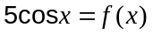 over the domain 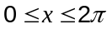.
(1 mark)
3 solutions

Question 5 (5 marks)
The exact values of the sine and cosine of 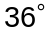are 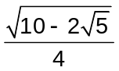 and 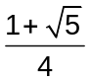 respectively.

Using the identities 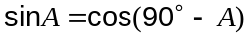 and 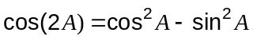, or otherwise, determine the exact value of the sine of 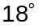 in the form 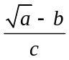, clearly stating the values of the positive integers , and .

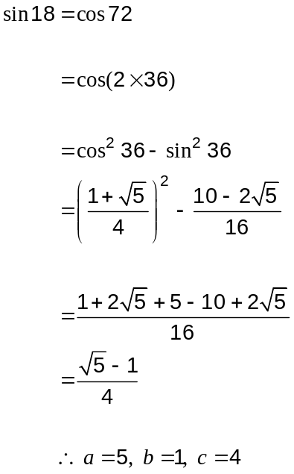

Question 6 (10 marks)
(a) A line passes through the points with position vectors 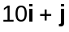 and 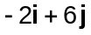. Determine a vector equation of the line through these two points in the form 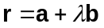, where is a unit vector. (4 marks)

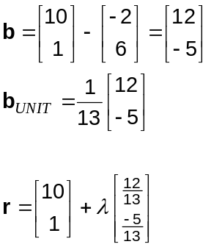

(b) The point A lies on the line with equation 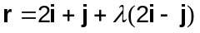 and the point B has position vector 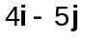. Use a method involving a dot product to determine the position vector of A so that the distance from A to B is a minimum. (6 marks)

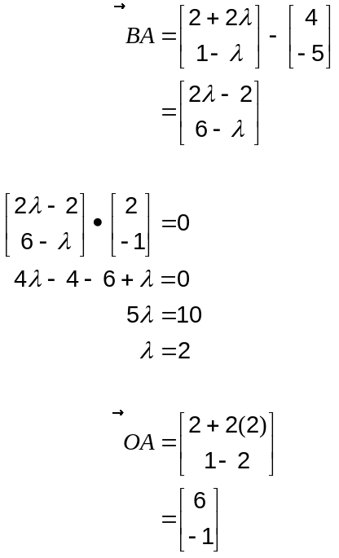

Question 7 (8 marks)
Solve the following over the given domains.

(a) 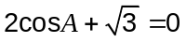, 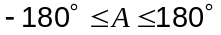 (2 marks)
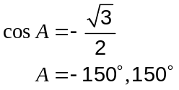

(b) 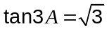, 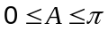. (2 marks)

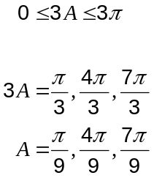

(c) 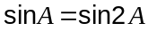, 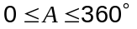. (4 marks)

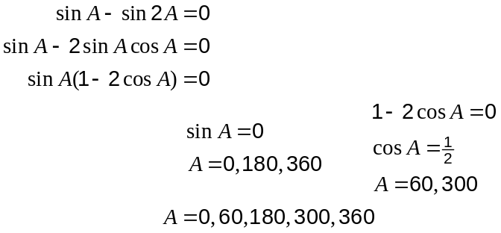

Additional working space

Question number: _________

Additional working space

Question number: _________

This examination paper may be freely copied, or communicated on an intranet, for non-commercial purposes within educational institutes that have purchased the paper from WA Examination Papers provided that WA Examination Papers is acknowledged as the copyright owner. Teachers within purchasing schools may change the paper provided that WA Examination Paper's moral rights are not infringed.

Copying or communication for any other purposes can only be done within the terms of the Copyright Act or with prior written permission of WA Examination papers.

Published by WA Examination Papers
PO Box 445 Claremont WA 6910

